1. Robert is given a task to implement a function that can check if a number is palindrome or not. If the number is palindrome the function would return false otherwise it will return true. The teacher asked Robert to implement the code in such a way so that it can check N numbers if they are palindrome or not.

First number would be N to take N numbers from the user. Next N numbers would be given input by the user

Ex. Input:

5

121 1221 12321 1 3

Output:

Yes Yes Yes Yes Yes

Ex Input:

1

34

Output:

No

1. Write a python function that would print the Pascals Triangle. User would input N and first N rows of Pascals Triangle would be printed below.

Ex Input

5

Output:

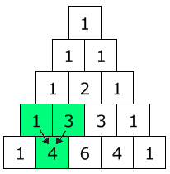

**Note: YOU ONLY HAVE TO PRINT THE NUMBERS IN A PYRAMIDAL FORMAT NOT THE BOXES AROUND THEM.**